Manuscript Title (16, Times New Roman, Bold)

First Author 1 , Second Author 2
Department, Faculty, University, City, Country.1
Department, Faculty, University, City, Country.2
*Corresponding author: xxxxxxxx@xxxx.com

Research Title in Arabic (16, Times New Roman, Bold)
First Researcher Name1, Second Researcher Name2
1 Department, College, University, City, Country.
2 Department, College, University, City, Country.

Received: May 12, 2024 Accepted: July 02, 2024 Published: July 10, 2024

Abstract
Type here (10, Times New Roman).
Keywords: Five words arranged alphabetically separated by comma

. Main Title (14, Simplified Arabic, Bold) Introduction
1Text written here (14, Simplified Arabic, Normal)
2. Main Title (16, Simplified Arabic, Bold) Subsection Title.
1.2. Subheading (14, Simplified Arabic, Bold) Requirement Title.
Text written here (14, Simplified Arabic, Normal).

Tables: Only the table title should be written in bold and the number and title of the table (1,2,3) should be placed directly above the table without a space, summarizing its content, and footnotes should be written briefly. The table should have borders only below the title and at the bottom of the table, without internal divisions or borders. The table must fit within the width of the page, with numbers in size 8, centrally aligned, and preferably formatted vertically (as much as possible) to facilitate reading without the need to turn the page. The table should be referred to by its number in the text before its placement, and the table should be placed immediately after being mentioned in the text whenever possible. Tables should always be referred to by their number, either before or after placement, and tables are numbered sequentially according to their mention in the text .

Table 1. Write here
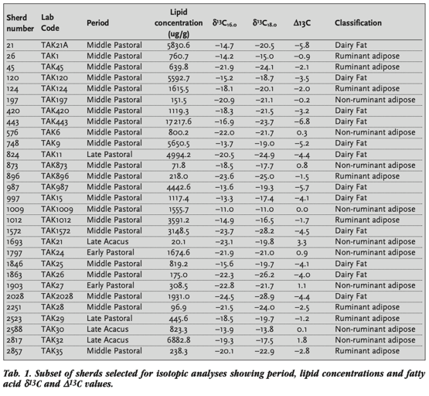
Figures and images: The number and title of the figure are written below it (images are treated the same as figures under the name of a figure). The figure is referenced by its number in the text before placing it and is placed directly after mentioning it in the text as much as possible. The figure is always referred to by its number whether before or after placing it, and it is numbered sequentially according to the order of its mention in the text. In graphs, a key is used to distinguish the lines of the graphs, and colors that are close to each other should not be used to facilitate the distinction of those lines after printing.
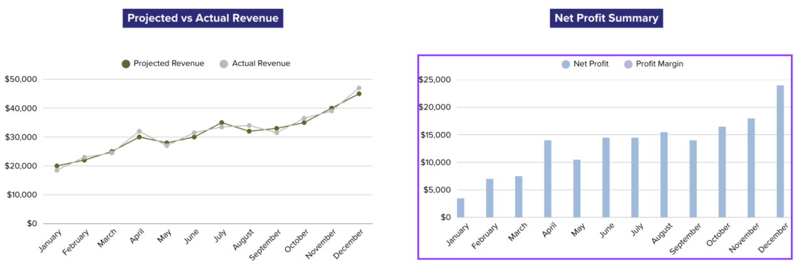
Figure 1: Written here

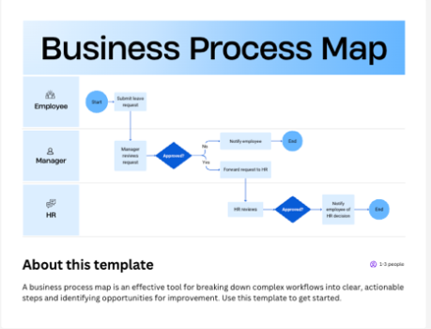
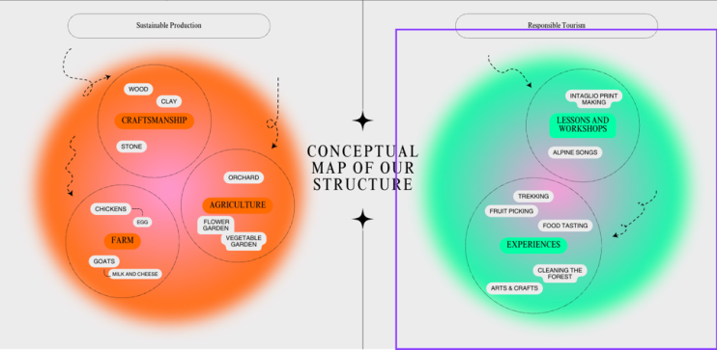

Figure 3: Write here. Figure 2: Write here .

. .Results and Discussion3
1.3. Subheading.
1.1.3. Second Subheading (14, Simplified Arabic, Bold)
Written here

4.Conclusions
Written here

References
List of references in Arabic :
Sources are listed according to the APA style

List of references in English:
Type according to APA style.

